EXCLUSION
POLICY

1

Introduction 1
A Definition of Wellbeing 1
No Need to Exclude 1
Aims of this Strategy 2
Guiding Principles 2
Framework for promoting social and emotional wellbeing 3
Outcome Indicators 4
A continuum of whole school and targeted approaches and interventions 4
Referral pathways 5
Continuum of provision for exclusion and alternatives to exclusion 6
Measuring Wellbeing 7
Pyramid of Approaches and Interventions 8
Whole School Behaviour Policy 9
Social Emotional Aspects of Learning (SEAL) 10
Restorative Approaches to Behaviour and Relationships 11
Solution Focused Approaches 12
Anti-Bullying 13
Mindfulness 14
The Solihull Approach 15
Staff Sharing 16
Peer Mediation 17
Pastoral Support Programme (PSP) 18
Re-engagement Unit 19
Circle of Friends 20
Team Teach 21
Parenting Programme 22
School Counselling Service 23
Nurture Groups 24
Personalised Timetables 25
Short term focused alternative provision placements at New Regents College 26
Education Health and Care Needs Assessment 27
In-year transfer 28
Managed Move 29
Fixed-Term Exclusion 30
Permanent Exclusion 31

Introduction
2
Our vision is for all children and young people in Hackney to be purposefully engaged in an educational programme appropriate to their needs and age. We want our children and young people to flourish and to achieve positive outcomes for themselves, their families, and our community and for society at large. We want our children and our adults to be happy, healthy, capable and engaged with school and the wider community. Minimal school exclusions will be a key indicator of our collective success.

National government recognises and promotes the importance of wellbeing in schools as a key factor in achieving this ambition (Mental health and behaviour in schools, DfE 2014). Hackney schools and Hackney Learning Trust have long been aware that improving the all-round wellbeing of pupils and staff is important in and of itself, as well as crucial in lifting performance and attainment levels.
“Pupils with better health and wellbeing are likely to achieve better academically”
(The Link between Pupil Health and Wellbeing and Attainment, Public Health England, 2014)
“Children with higher levels of emotional, behavioural, social, and school wellbeing, on average, have higher levels of academic achievement and are more engaged in school, both concurrently and in later years”
(The Impact of Pupil Behaviour and Wellbeing on Educational Outcomes, DfE, 2012)

A Definition of Wellbeing
“Wellbeing is about more than living ‘the good life’; it is about having meaning in life, about fulfilling our potential and feeling that our lives are worthwhile” (Eckersley 2005).

Social and emotional wellbeing provides the essential foundations for healthy behaviours and educational attainment. It helps prevent behavioural problems and mental illness. For the purposes of this strategy, the following definitions apply:
- emotional wellbeing – this includes being confident, happy and not depressed;
- psychological wellbeing – this includes the ability to be autonomous, problem-solve, manage emotions, experience empathy and be resilient;
- social wellbeing – this includes the ability to have good relationships with others and to avoid engaging in disruptive, aggressive or bullying behaviour (NICE, 2014).

No Need to Exclude
This good practice guide provides the reference point for all dedicated actions that have an impact on our children and young people’s wellbeing, including our approach to managing pupils’ behaviour.
Through this strategy we provide a directory of approaches and interventions, which we encourage and support our schools to consider. Our specific strategy is to work towards the position where the needs of all young people are addressed, and where schools no longer feel the need to exclude given the continuum of provision and support available to enable them to meet pupil needs.
Aims of this Strategy
3
- To provide our schools with a convincing rationale and a clear way of thinking about and working to enhance the wellbeing of all members of the school community.
- To ensure that our schools have easy access to the most useful and appropriate evidence (e.g. EEF, 2014) in deciding how to work to promote wellbeing.
- To encourage and support our schools to provide an emotionally secure environment that prevents bullying and provides help and support for children (and their families) who may have problems.
- To encourage and support our schools to have a whole school planned approach to help develop all children’s emotional and social wellbeing. It should be integrated into all aspects of the curriculum and staff should be trained to deliver it effectively.
- To encourage and support our schools to recognise the importance of staff wellbeing and the duty of care they have towards their staff. (e.g. Framework for promoting well-being and responding to mental health in schools, Weare, 2015)
- To ensure that school leadership is equipped to promote and enhance staff wellbeing in their school.
- To ensure that teachers and other staff are equipped to identify and support children at school showing signs of anxiety or social and emotional problems. Staff should be able to discuss the problems with parents and carers and develop a plan to deal with them, involving specialists where needed. (NICE recommendations; DfE recommendations)

Guiding Principles
We work in line with the following Hackney Children and Young People’s Services’ (CYPS) principles:
- A co-ordinated whole family approach: all services working with a child or other family members work in partnership to ensure a co-ordinated and integrated approach to support the family to promote the best outcomes for their children, and to ensure children are safeguarded.
- Demonstrating impact and effectiveness: all services are designed, commissioned and delivered on the basis of structured evaluation and clear evidence about what works to make the most effective use of resources.
- Early intervention and prevention: early and timely intervention is provided to prevent problems arising in the first place or escalating and becoming entrenched.
- Understanding community needs and engagement: services engage with children, young people, families and their communities to understand and meet their diverse needs.
- Improving life chances: services work together to improve educational outcomes and learning and work opportunities for all young people, particularly for vulnerable groups of children such as looked after children, children living in poverty, disabled children and children in contact with the youth justice system.

The diagram on the following page (Framework for promoting well-being and responding to mental health in schools, Weare, 2015) presents a framework for promoting the social and emotional wellbeing of the whole school community.
Framework for promoting social and emotional wellbeing
4
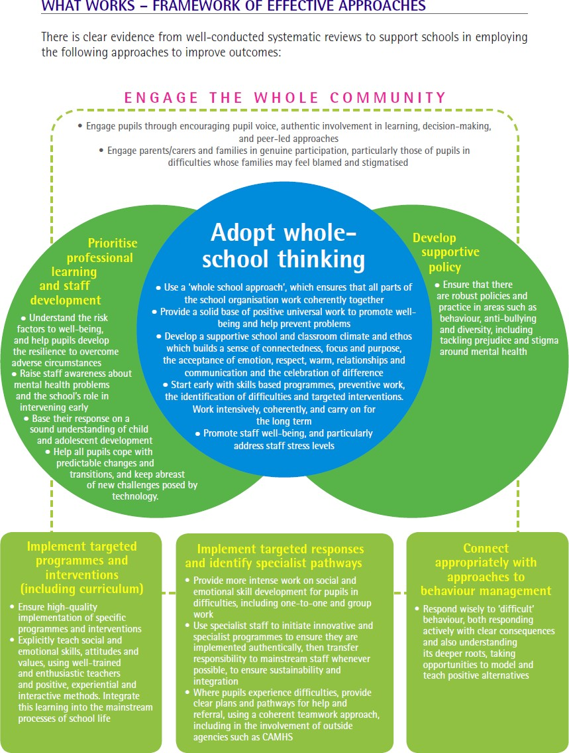

Outcome Indicators
5
We will know that we are on the right path when we are able to provide evidence that:
  - Pupil attainment is maintained or improved
  - Pupils feel safe in school
  - Pupils report increased personal and social wellbeing in school
  - Staff report increased personal and social wellbeing in work
  - School staff feel competent and confident in promoting children’s wellbeing
  - Schools are confident in responding to responding to their pupils’ needs
  - Pupil behaviour is improved and there is a reduction in ‘risky’ behaviour
  - Fewer pupils are excluded from our schools
  - Preventative mental health measures are in place and there is a reduction of concerns in addressing mental health issues
  - Children and families report productive engagement with the appropriate services

This strategy is consistent with the Hackney Child Wellbeing Framework which focuses upon child and family need, not thresholds for service. The framework defines three levels of response to presenting needs:

Complex/High Risk -
Child/young person’s needs require specialist services or a statutory response including Children’s Social Care investigation and/or intervention services

Universal Plus - Child/young person’s needs can be met by
universal services working together or with the addition of some targeted services
Universal - any identified additional needs can be
met by universal services

A continuum of whole school and targeted approaches and interventions
Given the array of educational, behavioural and therapeutic initiatives available that claim to promote wellbeing in schools, it can be difficult to know which ones to implement, when and for whom. This guidance seeks to clarify some of these questions for school practitioners.
The selection of approaches and interventions presented in ‘The Pyramid’ on page 8 represents a continuum ranging from universal through targeted to specialist. This presentation is one way that a school might think of identifying its own range of approaches and interventions. It is expected that all schools will have established a whole school approach to wellbeing built on the foundations identified.
It is expected that the selection of approaches, practices and interventions will be based on appropriate assessment of needs and resources. It is crucial for implementations to be monitored and evaluated for effectiveness.

Research evidence gathered over time indicates that the following principles are essential to the success of any intervention:
6
  - select interventions based on appropriate assessment of need
  - work to increase assets as well as reduce deficits (strengths based)
  - deliver good quality training to the people facilitating the intervention
  - adhere to the model
  - work with commitment and perseverance
  - record, reflect and review

Referral pathways
Good-quality implementation of the appropriate intervention will, in most cases mean that the children and families will not require any additional formal support. However, in those cases where different support is required, the first step would be a discussion at a school-based and school-led multi-agency planning and review forum, unless it is evident that there are child protection concerns which require an immediate referral to Children’s Social Care.

Most schools refer to this school-led forum as their Multi Agency Planning (MAP) meeting. It is a process to support the SENCo in managing the identification, coordination and review of support and interventions for pupils with additional needs. When the school assesses that the support and interventions agreed upon and implemented have not been successful in meeting the needs of the child, they can refer to a Multi Agency Team (MAT) for under 6 years old, or to the Children and Young People’s Partnership Panel (CYPPP) for young people aged 6 or over, via a referral to the First Access and Screening Team (FAST).

The diagram on the following page from research commissioned by the Office of the Children’s Commissioner as part of an investigation into school exclusions (Reducing inequalities in school exclusion - Learning from good practice) presents a continuum of provision for exclusion and alternatives to exclusion.

7
Continuum of provision for exclusion and alternatives to exclusion
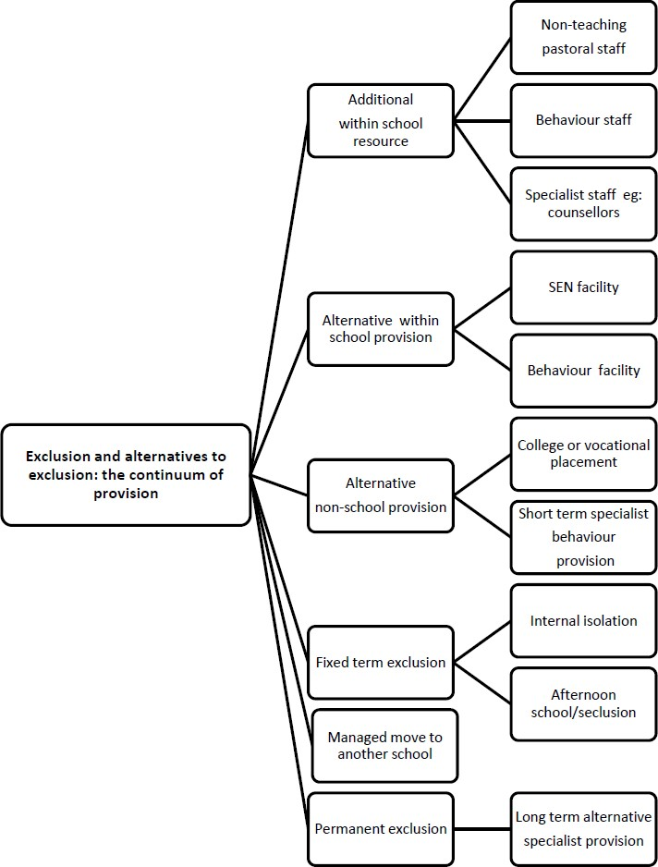

8

Alternative Interventions

Where it becomes apparent that despite the best efforts of the school, the child, the family and other agencies a particular child or young person is unable to have their needs met in a particular setting then it can be necessary to explore ways to integrate that child or young person into an alternative setting.
Details about managed moves and exclusion are included at the end of this guidance.

Measuring Wellbeing
Schools may wish to measure the well-being of staff and students at particular points and could construct a simple survey or use one of the many that are published for this purpose. In addition, schools will have a range of ways of identifying students who require more targeted or specialist interventions and can refer to Risk and Resilience Factors (youngminds). This will be part of a graduated approach. Where there are concerns, schools may wish to use a standardised instrument such as the Strengths and Difficulties Questionnaire (SDQ) which has versions for the student, staff and parents to complete. It is important to evaluate any interventions that are put in place. Ideally through a simple pre and post measure. These are sometimes part of published programmes. Agencies such as the Educational Psychology Service or CAMHS can advise about appropriate measures to use.

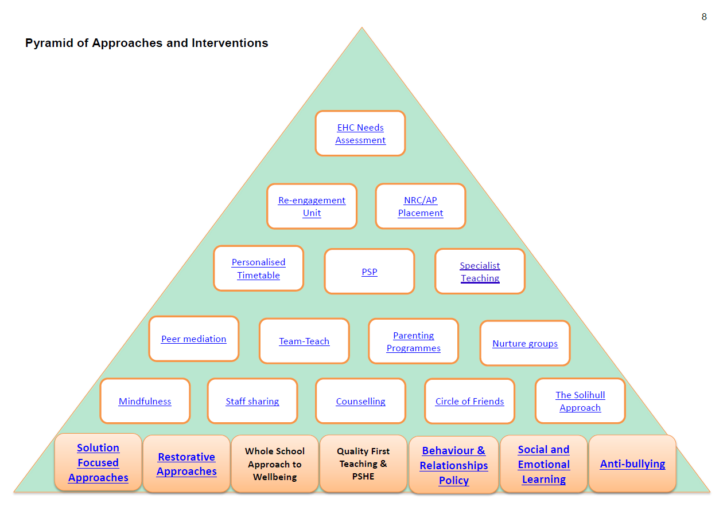
9

Whole School Behaviour Policy
10
A whole school behaviour policy should include the following principles:
    - Be fully integrated within daily teaching in order to promote positive behaviour for pupils and ensure effective behaviour management skills of staff
    - Ensure pupils who are regularly follow the rules are noticed and rewarded
    - Ensure pupils have the opportunity to make positive choices about their behaviour and influence outcomes
    - Be restorative in approaches to managing and changing behaviour.
    - Ensure pupils are supported to make and sustain changes in behaviour.
    - Ensure the systems and structures teach pupils positive behaviour, social and emotional skills
    - Be differentiated for pupils who require additional support with managing behaviour
The system should include:
    - A consistent approach used by all staff across the school
    - Opportunities for a range of rewards including whole class and individual rewards
    - A range of strategies to ensure staff use least intrusive approaches to manage behaviour
    - Opportunities for the teaching of specific behaviours and routines
    - Opportunities for pupils to reflect on and implement changes to behaviour
    - Systems for tracking rewards and consequences
    - Opportunities for consistent and constructive communication with parents

Why would we use it?
Hackney Learning Trust recommends the Stay on Green behaviour system. This is in place within many Hackney primary schools. External and internal inspections and moderation has shown this system to be a highly effective way to ensure that good or better behaviour and behaviour management supports teaching and learning.

How does it work?
A behaviour policy has a consistent system of rules, rewards and consequences.
The policy should set out clear expectations for behaviour and attitudes to learning. It should be supported by a school ethos that teaches social, emotional and behaviour skills. Examples of approaches to support a behaviour policy through teaching these skills include:
    - Daily whole class behaviour plenaries
    - The curriculum e.g. SEAL and PSHCE lessons, and opportunities built within all lessons
    - Circle Time
    - Philosophy for Children
    - School council
    - SEAL assemblies
    - Key interventions: Playground Friends, Peer Mediators
    - Interventions e.g. SEAL small group work
    - Family SEAL

How can we find out more?
A range of support and guidance can be accessed to support the implementation of a whole school behaviour policy and the Stay on Green behaviour system. For more information please contact: Claire Tregear, Associate Deputy Headteacher Behaviour and SEAL claire.tregear@learningtrust.co.uk 020 8820 7360
Social Emotional Aspects of Learning (SEAL)
Social, emotional and behavioural skills support pupils to positively engage in school and home life. They are fundamental to ensuring high standards of learning and attainment. Effective learning, high academic standards, an inclusive culture, positive behaviour and good attendance are challenging to develop unless pupils have social and emotional skills and the ability to manage their own behaviour.
11

Why would we use it?
Research has shown that pupils who have a range of skills with each of the five domains of SEAL, and are taught in a school environment that is supportive to emotional health and wellbeing, are more motivated and equipped to:
    - Be effective and successful lifelong learners
    - Make and sustain friendships
    - Manage and resolve conflict effectively
    - Manage stronger feelings like anger, anxiety and frustration
    - Persist when faced with difficulties (resilience)
    - Recognise and understand the thoughts and feelings of others
    - Respect others’ beliefs and values may be different to their own

How does it work?
To support the implementation of a whole school SEAL ethos and the curriculum, Hackney Learning Trust recommends the following:
- Wave One:
  - Consistent use of a whole school behaviour policy based on SEAL principles e.g. Stay on Green
  - A whole school SEAL assemblies during each SEAL theme
  - Teachers teaching whole class SEAL lessons using the SEAL curriculum booklets and its resources as discrete lessons as well as planning cross curriculum links
  - Whole class Circle Time lessons to give pupils opportunities to practice the SEAL skills taught
  - Word of the Week
  - Staffroom Activities
  - Additional interventions to promote SEAL principles e.g. Peer Mediation
- Wave Two:
  - SEAL Small Group Work KS1 and KS2
  - Family SEAL
Materials to support the implementation of a whole school SEAL ethos and the curriculum are:
- SEAL curriculum booklets and resources
- SEAL Small Group Work KS1
- Hackney Learning Trust SEAL Small Group Work KS2
- Hackney Learning Trust Family SEAL
- Hackney Learning Trust SEAL Assessment Guidance Booklet
- Hackney Learning Trust Securing Good or Better Programme

How can we find out more?
A range of support and guidance can be accessed to support the implementation of SEAL. For more information please contact:
Claire Tregear, Associate Deputy Headteacher Behaviour and SEAL claire.tregear@learningtrust.co.uk 020 8820 7360

Restorative Approaches to Behaviour and Relationships
12
Restorative Approaches are a range of practices used to promote positive relationships and behaviour in schools. They range from informal Restorative Conversations and Restorative Enquiry through to Restorative Mediation, Mini-Conferences and full Restorative Conferences.

The term ‘Restorative Practices’ is used in education to mean:
- restoring good relationships when there has been conflict or harm;
- developing school ethos, policies and procedures that reduce the possibilities of such conflict and harm happening.

“Restorative Practice is a philosophy, in action, that places the relationship at the heart of the educational experience. Restorative work in school communities builds and maintains inclusive networks of positive relationships. A range of specific restorative tools are used to restore these relationships where harm and misconduct occur.”
(Corrigan, NZ Ministry of Education, 2012)

Why would we use it?
Restorative Practice has been shown to build a school culture where the climate for learning is improved so enabling learners to learn and teachers to teach. Restorative Practice has also been shown to be a highly effective tool in improving behaviour and reducing exclusions. Engaging with Restorative Practice can enable your school to develop the competence and confidence of staff to promote positive behaviour and to deal constructively with negative behaviour.

How does it work?
Restorative Practice is about asking the questions:
- What happened?
- Who has been affected and how?
- What’s needed to make things right?
- How can we make sure this doesn’t happen again?

There is a continuum of Restorative Practice in schools from the 2-minute Restorative Chat to the high- level Restorative Community Conference. Restorative work can be done with individual pupils and staff, groups of pupils, the whole class and at the whole school level. Used reactively, Restorative Practice is a form of constructive conflict resolution. Used preventatively, Restorative Practice is a selection of encounters such as a classroom conference or a peer mediation scheme that is a planned intervention that can build strong relationships and increase emotional literacy among pupils and among staff.

How can we find out more?
Restorative Approaches in Schools in the UK
Terence Bevington, Restorative Approaches Coordinator Terence.bevington@learningtrust.co.uk 020 8820 7551
Solution Focused Approaches
13
The main principles of the approach are to support people (including children, young people and families) in making a shift from being problem –focused to being solution-focused. This is achieved by holding a core set of beliefs when working with others:
  - We don’t need to fully understand the problem before we can find a solution
  - Everyone has the strengths and resources to help themselves
  - There will already be something that is working
  - Change can happen in very small steps
  - No matter how bad the problem is, it doesn’t happen all the time
  - We can’t change the past so we should focus on the future
  - Having a clear idea where you want to be makes it more likely that you will get there

Why would we use it?
Several studies have found good outcomes following use of the approach in therapeutic settings. There is more research being undertaken in schools and other settings. A research summary is available form BRIEF. Research indicates that only a small number of sessions are required. Some of the measurable outcomes are a reduction in reoffending rates, reduced measures of depression and increased scores on measures of parenting skills.
Solution focused approaches have been used in schools to support young people experiencing difficulties with anxiety, friendship issues, reading difficulties and social and behavioural difficulties.

How does it work?
Once the main principles of the approach are understood it can be applied in a number of ways and a wide variety of situations:
  - Whole school approaches to support staff and pupils in developing high standards of teaching and learning (Solution Oriented School Programme, Rees, 2005)
  - Individual work with children and young people – coaching rather than counselling
  - Group or class work – finding out what is working and what change would look like
  - Meetings with colleagues, parents and families, children and young people
  - Training and large group meeting to gain positive outcomes
  - Supervision and personal reflection
  - Organisation reviews
  - Use of video feedback (Video Interactive Guidance)

The solution focused approach sounds simple but requires training and practice to implement. Teachers can become solution focused with practice and begin to notice much more positive behaviours to build upon. This supports quality teaching and relationships with children, young people and families that can support positive change.

How can we find out more?
BRIEF - Europe's largest provider of solution focused Brief Therapy training

The Educational Psychology Service Siobhan.currie@learningtrust.co.uk

Anti-Bullying
14

“Bullying is behaviour by an individual or group, repeated over time, that intentionally hurts another individual or group either physically or emotionally” (DfE, 2014, p. 6).

Schools have a duty to prevent bullying and to respond to incidents of bullying.

Section 89 of the Education and Inspections Act, 2006 provides that “every school must have measures to encourage good behaviour and prevent all forms of bullying amongst pupils. These measures should be part of the school’s behaviour policy which must be communicated to all pupils, school staff and parents”.

How does it work?

Schools will have in place a policy on anti-bullying in which it clearly lays out its principles and practices to promote positive behaviour and relationships to prevent incidents of bullying, as well as its interventions to respond robustly to incidents of bullying.

How can we find out more?

More information on how to promote positive behaviour and relationships to prevent bullying and how to respond to bullying is available from:

Hackney CYPS Preventing Bullying Statement

Anti-Bullying Alliance (ABA)

Mindfulness
15

What is it?
Mindfulness is the awareness that arises through training in paying attention to present moment experiences in a kind, open-minded and non-judgmental way. It is developed through formal practices done sitting, moving or lying down and informal ones that can be integrated into everyday life.

Why would we use it?
There is good evidence from neuroscience and brain imaging studies with adults that regularly practicing mindfulness meditation can reliably and profoundly alter the structure and function of the brain, improving the quality of thought and feeling and bringing a wide range of benefits, including improved mental and physical health, wellbeing, learning and cognition and social and emotional skills.
Research on mindfulness with school-age children has included all age ranges of children both with and without mental and physical health problems. Studies have taken place in school, clinical and community contexts. Training in mindfulness for young people is easy to implement, fits into a wide range of contexts, is enjoyed by both students and teachers, and does no harm. The benefits include:
  - Improved mental, emotional, social and physical health and wellbeing.
  - Reduced stress, anxiety and reactivity and improved ability to manage behaviour and emotions.
  - Improved sleep, calmness, self-esteem, self-awareness and empathy
  - The development of cognitive and performance skills and executive function, including to improve working memory, planning, problem-solving and reasoning skills.
  - Greater attention, focus and ability to think in more innovative ways.

How does it work?
Mindfulness training is provided by HLT’s Educational Psychology Service and associates. There are three levels of training/ intervention depending on the needs of the child/ young person, family and school setting. This follows the Hackney Child Wellbeing Framework:
The MBAT intervention was developed through doctoral research and the Dot-b, Paws Dot-b and Dot-b Foundations programmes were developed by the Mindfulness in Schools Project.

Complex/ High Risk Cases
Universal Plus
Universal
Whole staff training in well-being: INSET sessions and “dot-b Foundations” course (a prerequisite to further training to teach mindfulness to pupils).
Whole class training for pupil well-being: "dot-b" for secondary and "Paws dot-b" for primary pupils
The Mindfulness-based Awareness Training (MBAT) is a be-spoke intervention designed for complex casework. It includes consultation with school staff, family and professionals, individual sessions and group work (if possible) with child/ young person.

How can we find out more?
Dr Bernadette Carelse, Educational Psychologist bernadette.carelse@learningtrust.co.uk
Services for Schools page on Mindfulness in Schools
16
The Solihull Approach
The Solihull Approach is a highly practical way of working with families within a robust theoretical structure. It is an early intervention model and is also used in preventative and group work. The approach is a synthesis of theory from child psychotherapy, child development and social learning theory. The focus is upon Containment, Behaviour management and Reciprocity as key ways to work with the child and family.

The Solihull Approach has a major contribution to make to the ways in which practitioners in health, education, voluntary and social care can work with families to ensure that children have a good emotional start in life. It is used by a wide range of professionals working with families with children who are affected by emotional and behavioural difficulties. It is recommended as part of the Healthy Child Programme.

Professionals from across health, early years, social care and education have been trained in the Solihull Approach and use the approach to inform a shared language for working effectively with children and families.

How does it work?
The Solihull Approach works by improving understanding about children’s behaviour and enabling adults to use containment, reciprocity and behaviour management to improve relationships and support children and families. For schools the Solihull Approach can provide a framework for teachers and support staff to work with pupils and families. Teachers find that it really helps in their understanding of children with emotional and behavioural difficulties and in the strategies and approaches they can use in class.

How would we use it?
Solihull Approach is an ‘approach’ that can be integrated into the way staff currently work with children, young people and families. A whole school training based upon the Solihull Approach, called Understanding Your Pupil, is also available and schools in other boroughs, such as Islington, have had all staff trained in this approach.

First Steps run a 10 week group intervention for parents with children aged between 0-5 which is based up on the Solihull Approach and is called Understanding Your Child. This is run three times a year and rotates venue around the borough. The group is recommended by NICE as well as being the first group for parents to receive the new Department for Education CANparent Quality Mark.

How can we find out more?
https://www.evidence.nhs.uk/search?q=solihull%20approach

For further information and to discuss whether Solihull Approach could be helpful in your school please contact:
Educational Psychology Service: rajinder.sodhi@learningtrust.co.uk 020 8820 7519

or
First Steps Early Intervention and Community Psychology Service James.Bourne@homerton.nhs.uk 020 7683 4611

Staff Sharing
17
Staff sharing is an actioned based approach which is designed to assist teachers to become more effective in managing challenging behaviour.
The scheme involves an EP training a group of staff in a range of techniques, such as behaviour observations, analysis and management as a process for measuring and modifying problem situations and behaviour. Once training is completed the staff sharing group meets regularly to suggest, devise and evaluate interventions employed within the school.

Why would we use it?
You may use the approach for an individual pupil, a class, or a year group where some or all staff have identified challenging behaviour.
The scheme assist staff in taking collective responsibility for developing their own problem solving networks, by challenging existing belief systems, but also drawing upon effective practice within the school. By working as a team established issues can quickly be addressed and the misconception of a challenging student merely being one person’s responsibility is replaced with a collective responsibility.

How does it work?
Once the staff have been trained in the techniques, the staff group meet initially with the educational psychologist. Any member of the group can present an issue relating to a concern that they have about any aspect of behaviour within the school.
All staff are encouraged to comment on the concern identifying where there have been exceptions. It may be recognised by the group that more data is required, or that a specific intervention is required. Staff will agree how and who is best placed to deliver the intervention, as well as how best to evaluate its effectiveness. At the next meeting the intervention is reviewed and modified if required.
The approach has been found to be effective in reducing teacher stress as well as improving the outcomes for pupils as a result of greater consistency in behavioural management.

How can we find out more?

Beverley Graham, Educational Psychology Service Beverley.graham@learningtrust.co.uk 020 8820 7519

Peer Mediation
18
Peer Mediation is a process whereby people involved in a dispute enter voluntarily into an arrangement to resolve the problem with the help of a mediator. By establishing agreed ground rules for the conduct of the mediation, a neutral mediator enables the participants to identify the issues by talking about the situation from their own point of view, to be heard by the other participant(s), and to say what their preferred outcome would be. Together, the participants then draw up an agreement. The mediator neither gives advice nor imposes a solution; responsibility and control rest with the participants.

Why would we use it?

As has been reported in the evaluation literature, peer mediation programmes benefit both children as individuals and schools as institutions. They have been shown to improve pupils’ self-esteem and relationships, give children a greater sense of responsibility, reduce conflicts, promote academic achievement, develop life-skills, allow teachers to focus on teaching, and create an environment in which pupils can learn and socialise safely and constructively.

How does it work?

Peer mediators undergo a minimum of two days’ training to equip them. Once trained, the peer mediators work in pairs, invariably with pupils younger than themselves.

Peer mediation is a very matter-of-fact, logical, linear process, whereby children help each other to deal with their conflicts, playground disputes, and so on. It is a structured process, managed by two mediators, who are children. They introduce the process, establish ground rules, listen to the story from the perspective of each of the disputants and offer to each of them a summary of what he or she has said. They then provide the opportunity for both sides to voice their feelings, help them identify the problems, brainstorm solutions, and, ideally, agree a solution. Mediation is a voluntary process, so if either of those in dispute decides that he or she doesn’t want to go ahead at any stage, he or she doesn’t have to. In that instance the conflict is usually dealt with according to the school’s standard discipline policy.

How can we find out more?
Claire Tregear, Associate Deputy Headteacher Behaviour and SEAL claire.tregear@learningtrust.co.uk 020 8820 7360
Terence Bevington, Restorative Approaches Coordinator terence.bevington@learningtrust.co.uk 020 8820 7551

Pastoral Support Programme (PSP)
19
A Pastoral Support Programme (PSP) is a school-based intervention that is designed to support young people who are at risk of permanent exclusion, or who are at risk of becoming disaffected through repeated fixed-term exclusion. It is part of a continuum of provision for pupils with behaviour, emotional or social difficulties. The decision to implement a PSP will be made in conjunction with the school behaviour policy, as a strategy to promote inclusion. It is recommended that the school implement a range of interventions to support behaviour, emotional or social difficulties prior to the use of a PSP.

Why would we use it?
National guidance recommends that a PSP should be considered where one or more of the following apply:
  - A pupil whose behaviour is rapidly deteriorating and where previous planning to support behaviour and/ or learning has been unsuccessful.
  - A pupils who has had two or more fixed term exclusions.
  - A pupil who has had one fixed term exclusion of ten days or more.
  - A pupil who is at risk of permanent exclusion.
If a pupil is returning from an exclusion of ten days or more it is recommended that a PSP is developed prior to the pupil returning to school. This will enable the programme to support the reintegration process once the pupil returns to school.

How does it work?
The PSP is designed to bring together views and solutions from a variety of perspectives. It is a multi- agency meeting with a focus on the needs of the pupil. It includes views of parents or carers, the pupil, the school and other services involved with the pupil. The PSP is an outcome driven plan with targets set for the pupil, the school, the family and other agencies involved in supporting change.
A PSP:
  - is school based
  - is time-limited
  - has smart targets with practical strategies
  - is overseen by a school leader e.g. Inclusion Manager, SENCo, member of the SMT
  - follows a standard format so involves minimum administration
  - includes the views of the young person and their family
The most successful PSPs are developed when all the agencies involved with the young person are asked to contribute to the programme. One staff member, preferably a member of the school leadership team, should be responsible for overseeing the PSP.
An integral part of a Pastoral Support Plan is the reviewing process. The reviewing process tasks place every three to four weeks and targets are amended and developed in response to pupil progress. If the PSP is not having the required impact after two reviews schools may wish to contact the Re- engagement Unit or the school Educational Psychologist for further support.
Schools that undertake work with the Re-engagement Unit and Lower Regents School will be asked to provide a PSP (or similar) as evidence of work previously undertaken with the pupil. Support from these services will include advising schools on the use of a PSP as a tool to maintain inclusion and sustain improvements in behaviour.

How can we find out more?
20
Claire Tregear, Associate Deputy Headteacher Behaviour and SEAL claire.tregear@learningtrust.co.uk 020 8820 7360

Re-engagement Unit
The Re-engagement Unit (REU) is a school support service that is available to all maintained primary schools in Hackney. It undertakes a systemic approach to delivering support to children at risk of exclusion, and works with the family, school and child to create a framework which can help to deliver long term change.
Each child will have a unique pathway and plan depending upon his or her circumstances and every plan will be guided by targets set and agreed by the school, family and child at the outset of the work. Work undertaken by the REU will dovetail with the existing Pastoral Support Plan (PSP).
The REU works with schools and parents to identify and provide the intervention that is most suited and will have the greatest impact. Drawing upon the varied expertise within the team and its wider partnerships, the unit is able to tailor the intervention to ensure a ‘best fit’ with each family’s circumstances. The main delivery centres for the programme will be at school and in the family home.
The unit will respond only to referrals from schools in order to ensure all resources are directly benefiting the experience of Hackney primary schools; and that all work is undertaken with a view to improving the educational experience and outcomes of children and young people.

Why would we use it?
Schools refer to the REU because they have high level concerns around the behaviour and wellbeing of children in their care. The children referred to us are at risk of exclusion, and may even have had one or more fixed term exclusions.
A school can expect prompt, skilled support in developing personalised, consistent approaches to supporting at-risk children, and accountability and involvement from the outset. The REU supports schools and families to rebuild relationships, and supports the systems around the child to change and develop to better meet the needs of the child.
The REU has a multi-disciplinary team, which draws upon a wide skill set, including education, social care, pastoral management, youth work and mental health clinicians.

How does it work?
An email exchange, telephone conversation or initial meeting can be made prior to a formal referral. The initial referral will be discussed with Ebru Karatufek, the current Unit Leader. Following this the case will be allocated to a lead worker who will support the child, family and school directly throughout the plan. Referrals can be made using the existing PSP and completing the REU coversheet, found in the Re-engagement Unit Service Guide.
The lead worker will undertake a robust planning period, during which they will observe the child (often more than once), visit/meet the family, meet with all relevant school staff and all involved professionals (such as Children’s Social Care, CAMHS etc). Following this, a plan will be put together which fits into the current provision. Targets for our work will be agreed with all involved- these will need to have sign- off from the head teacher at the school. A mid-programme review date (involving school, REU and family, and other relevant agencies) will be set at this point to ensure there is an opportunity to redirect any interventions which are not having the required effect, and also to provide an opportunity for reflection on progress and success.
On exiting the re-engagement programme the child, family and school will work with the unit to put together a sustainability plan which will detail how progress will be maintained once the unit has withdrawn, and this plan will usually be linked to the existing PSP. In many cases, this will include the drawing together of a network of support services to manage different areas of concern identified by the school, the child and the family and ensure continued success and progress.
21

How can we find out more?
Ebru Karatufek, Re-engagement Unit Acting Manager Ebru.Karatufek@learningtrust.co.uk 0208 820 7091
Helen Grice, Re-engagement Unit Administrator Helen.Grice@learningtrust.co.uk 0208 820 7117

Circle of Friends
Circle of Friends was formulated out of the recognition that problem situations can’t be considered on an individual level alone, and that any change in behaviour is more likely to be maintained if members of the peer group are involved to move the situation forward. In addition to benefiting the problem child, it was also noted that the intervention could be a ‘rich learning experience for all members of the circle’. Six key themes of improvement were identified – development of empathy, identifying and expressing feelings, improvement in social problem solving skills, listening skills, being better at making links between feelings and behaviours and increased awareness of an individual’s power to change. A circle of friends is a peer group support network for a child about whom there is concern (focus child).
Members of the group are involved in moving the situation forward, making them aware of their contribution to any changes in the focus child, and thus positively affecting their expectations and perceptions of him/her.

Why would we use it?
As a means of promoting the inclusion of children with Special Educational Needs, primarily those with EBD in mainstream schools. Construction of a group of friends ensures that the emotional and behavioural needs of the focus child may begin to be met. In these ways, it is intended that the child or young person is able to change in their everyday context and that this change is maintained.

How does it work?
The ‘circle of friends’ approach works by mobilising the young person’s peers to provide support and engage in problem solving with the person in difficulty. ‘Circle of friends’ is not the same as ‘circle time’ but many of the skills and techniques used by teachers in ‘circle time’ can be used to support the ‘circle of friends’ process. It is essential that the focus child and their parents/carers accept and support this activity taking place and give consent for it to do so. A key member of staff must be committed to using the approach and able to give sufficient time to supporting the Circle of Friends. Circles of Friends are usually set up by the class teacher with support from an educational psychologist. During weekly sessions the group agrees ways in which they could support the focus child. As a result, targets for the following week are set, and then reviewed at the subsequent session.

How can we find out more?
More details on the procedure can be found at: http://inclusive-solutions.com/circle-of-friends/
22
For further information and support, please contact the Educational Psychology Service: EPS.Admin@learningtrust.co.uk 020 8820 7519

Team Teach

Team-Teach is a behaviour support training programme designed to help safeguard people and services. It is the largest such programme in the UK with over 5000 registered trainers and it has been established for over 15 years. It provides an accredited training framework to develop positive handling skills in behaviour management including verbal and nonverbal communication, diversion and de- escalation and safe, effective, humane physical interventions.

The Hackney Learning Trust has been using the Team-Teach (positive handling) approach within Hackney Schools since 2006 and a number of schools have now been successfully trained. Team- Teach is the largest provider of training for mainstream and specialist schools in the UK. The training takes place as part of a whole school approach to managing behaviour. The emphasis is always on preventative approaches and stresses that 95% of interventions should be non-physical.

Why would we use it?

- To develop behaviour management techniques, including physical restraint.
- To gain an understanding of legislation and guidelines surrounding physical restraint.
- To develop policies and procedures for positive handling within the framework of current legislation and guidelines.

How does it work?

The training is for all staff members to attend.
- A one-day (6 hours) foundation course is suitable for mainstream settings
- A two- day (12 hours) basic course is required for specialist provision.

How can we find out more?

The Hackney Learning Trust has retained Alastair Reid (principlal tutor) from Team–Teach to train staff in Hackney schools at a reduced cost to schools.
- For further information, visit www.team-teach.co.uk
- To request training, contact Alistair Reid on alastairreid@blueyonder.co.uk

Parenting Programme
Parenting programmes help parents understand their children’s needs. They range from those that aim to support parents in general to cope better with raising a child, to those that work with parents facing specific difficulties. In working with parents, professionals can help parents to strengthen parent-child relationships, find new ways of dealing with challenging behaviour and become better equipped to recognise the importance of their role.
23
There are 4 core theories which underpin the majority of them:
- Social learning theory, teaches parents strategies for dealing with challenging behaviours, such as time out and withholding privileges, and encouraging positive behaviour through proactive reward systems such as sticker charts and point systems.
- Attachment theory
- Parenting styles theory
- The model of human ecology
Why would we use it?
The National Institute for Health and Clinical Excellence (NICE) and Social Care Institute for Excellence (SCIE) following a review of the research evidence, published guidance recommending the use of parenting programmes in the management of children with conduct disorders particularly up to the age of 12.
There is evidence which suggests that group programmes are more cost effective than those run on an individual basis. Parenting programmes impact on the wellbeing of the whole family and can lead to improved outcomes for children and young people.

How does it work?
The groups are led by a trained facilitator who meet with parents on a weekly basis in school or local community setting to work on skills to help them support their children. The sessions can involve reviewing DVD footage of family behaviour, group discussion and rehearsal of skills. Parents are encouraged to try out the strategies at home and then feedback the following week. The groups are designed to be supportive and enjoyable.
Educational Psychologists (EPs) in Hackney co facilitate in delivering Early Bird and Early Bird Plus programmes with Speech and Language Therapists and Specialist Teachers. These are specifically designed for parents of children with autism or a social communication disorder.
The Educational Psychology Service offers schools the Incredible Years programme facilitated by an EP as part of the traded services strand. Schools could join together to offer the programme.
Bespoke parenting programmes are also on offer to schools and similarly come out of the traded services strand. Other programmes are offered by a range of professionals in Hackney.

How can we find out more?

Commissioning Tool Kit / programmes

Parenting Programmes in Hackney

Incredible Years Programme

Siobhan Currie, Educational Psychology Service Siobhan.currie@learningtrust.co.uk 020 8820 7486

School Counselling Service
24

- A school counselling service is there to provide emotional support and to maintain the wellbeing of all within the school community. Counselling is a type of talk therapy that allows the individual to talk about their feelings and problems in a safe environment.
- The sessions are there for both pupils and staff, to encourage people to express their feelings and emotions. By discussing any of your concerns with a counsellor. This can help to gain a better insight and understanding into feelings as well as identifying ways of finding solutions to the problems.
- Counselling may be offered as a single session, as a short course of sessions over a few weeks or months, or as a longer course that lasts for several months or years.

Why would we use it?

Counselling can help people:

- cope with a bereavement
- explore difficult or distressing personal issues such as relationships with family and or friendships
- cope with anxiety and help people to worry less
- explore issues such as sexual identity
- deal with issues that are preventing them from achieving
- explore feelings such as sadness
- help people to have a better understanding of themselves.
- feel more confident

How does it work?

- Confidentiality: All information shared and content is talked about in the sessions, remains confidential unless the person or others are at serious harm.
- 1-1 sessions that are either a single session, time limited a few weeks or months or of longer for 2 years.
- Parents can request for their child to see a School Counsellor
- There are set weekly appointments
- The sessions are individual and face to face

How can we find out more?

The school counselling service in Hackney schools is provided by A Space, an established therapeutic service working in partnership with Hackney Learning Trust.

Nurture Groups
25
Nurture groups have an evidence-base in practice and offer a short-term, inclusive, focused intervention that works in the long term. Nurture groups are classes of between six and 12 children or young people in early years, primary or secondary settings supported by the whole staff group and parents. Each group is run by two members of staff. Children attend nurture groups but remain an active part of their main class group, they spend appropriate times within the nurture group according to their need and typically return full time to their own class within two to four terms. Nurture groups assess learning and social and emotional needs and give whatever help is needed to remove the barriers to learning. There is great emphasis on language development and communication. Nothing is taken for granted and everything is explained, supported by role modelling, demonstration and the use of gesture as appropriate. The relationship between the two staff, always nurturing and supportive, provides a role model that children observe and begin to copy. Food is shared at ‘breakfast’ or ‘snack time’ with much opportunity for social learning, helping children to attend to the needs of others, with time to listen and be listened to.
As the children learn academically and socially they develop confidence, become responsive to others, learn self-respect and take pride in behaving well and in achieving. Nurture groups have been working successfully for more than 40 years in the UK and now in other countries including Canada, New Zealand and Romania, and have been praised, supported and recommended by organisations such as Ofsted, Estyn and HMIE.

Why would we use it?
Nurture group classrooms are set up to bridge between home and school, where the missed learning opportunities are addresses according to the individual profile of needs. Nurture rooms are warm and welcoming places, with time to play within the highly structured and planned learning environment.
Effective communication is vital for academic progress and social acceptance. Many nurture group students have difficulty with receptive and expressive language often just through the lack of appropriate experiences. They are often anxious about talking when they enter a nurture group, which further inhibits their ability to make personal progress on a social, emotional, behavioural or intellectual level.

How does it work?
Using a range of strategies including games and songs, staff engage students’ attention and encourage them to listen and talk. A core principle of nurture groups is that all behaviour is communication and this aspect is fully addressed within this approach.
Staff also listen carefully to students, and repeat and rephrase their articulations in order to broaden the vocabulary of the student as well as to enhance their understanding of their own emotions. If there are arguments within the group, staff encourage the students to use the opportunity for growth by discussing alternative coping strategies for similar situations in the future. The students grow in self- control and self-respect as they improve their ability to talk clearly and confidently are able to express their needs.

How can we find out more?
www.nurturegroups.org
Nick Corker, Headteacher of Virtual School Nick.Corker@Hackney.gov.uk 020 8356 5016

Personalised Timetables
26

A part-time timetable drawn up for a pupil as a strategy to work towards their full reintegration into school.

Why would we use it?

In very exceptional and specific circumstances it may be necessary to develop a temporary part-time timetable to meet a pupil’s individual needs. For example where a medical condition prevents a pupil from attending full-time education and a part-time timetable is considered as part of a re-integration package. A part-time timetable must not be treated as a long-term solution. Any pastoral support programme or other agreement must have a time limit by which point the pupil is expected to attend full-time or be provided with alternative provision.

In most cases, consideration of a personalised timetable will be for two reasons:

- As part of a reintegration approach for pupils who have not attended school for a period of time due to illness, disability, mental health issues, family circumstances, or following an Alternative Provision placement.

- As a method for managing pupils that are exhibiting challenging behaviour and at risk of exclusion.

How does it work?

Personalised timetables need careful consideration prior to implementation and must have the support and agreement of the parent. Only the Headteacher, (or, in the absence of the Headteacher, the acting headteacher or teacher in charge) can place a pupil on a reduced timetable. Schools have a statutory duty to provide full time education for all pupils. In exceptional circumstances, schools may reduce the amount of time in any one day that a pupil spends in school.

How can we find out more?

Billy Baker, the Pupils Out of School Team Billy.baker@learningtrust.co.uk 020 8820 7569

Short term focused alternative provision placements at New Regents College
27

NRC (Lower) offers a short term placement of 6 weeks; this consists of
- 5 weeks intensive work
- 1 week of reintegration back into the pupil’s mainstream school.

Why use it?
While at New Regents the pupils will get support in and get the opportunity to develop in the following areas:
Anger Management - designed to help individuals learn how to control their anger more effectively and lessen the impact their anger problems are having on their lives and those around them.
Self Esteem – to support pupils to have positive yet realistic views of themselves and their situations.
Interaction Strategies – for pupils whose behaviour is disruptive or impulsive enough, to cause serious problems at school. We support by helping to restructure interactions with school, peers, etc.
During the placement we employ a range of proven approaches including:
Art Therapy and Drama Therapy - to facilitate personal growth and promote mental health and well-being.
Relaxation Techniques - relaxation can help to relieve the symptoms of stress. It helps pupils to calm down and to take a step back from a stressful situation.
Behaviour Modification - is a great way to address a variety of behaviour problems. It is often used to shape behaviour one step at a time. It can be very effective when working with pupils with ADHD, autism or oppositional defiant disorder.
Child Led Play - pupils practice necessary skills such as overcoming obstacles, creative problem- solving (with or without others), communicating their feelings effectively with others, and working with those who may have different points of view.
During the placement each pupil will have the opportunity to experience success in achieving individual short term goals
SEN Assessments
As a school we will support the mainstream school in this process and work with the professionals supporting the pupil at their mainstream school. The period will also give the school the opportunity to evaluate and amend its strategies for the young person on placement.

How does it work?
Following receipt of a formal referral we will arrange a meeting with the pupil’s school to determine whether New Regent’s is the right placement for the pupil. We will discuss the SMART targets identified by the school and book an end of placement meeting in week 5 to prepare for the pupils reintegration back into their mainstream school. During the placement New Regent’s will supply the school with fortnightly reports on the pupil’s progress in relation to the SMART targets as well as an end of placement report with strategies, recommendations and advice for the school on how to support the pupil when they return back to school. As part of the placement we require a member of the school to visit to maintain the connection with the pupil and to make preparations for the pupil’s return back to them at the end of the 6 weeks.
28

How can we find out more?
admin-regents@newregents.hackney.sch.uk

Education Health and Care Needs Assessment
The EHC needs assessment is a statutory assessment under the 2014 Children and Families Act. The Special Educational Needs and Disability Code of Practice (www.gov.uk/government/publications/send- code-of-practice-0-to-25) sets out how children and young people (0 – 25) should have their special educational needs identified through a plan, do, review approach in schools and other educational settings and the processes involved in an education health and care needs assessment.

Why would we use it?
When a school with the involvement of the child, young person and family consider that the school is not able to meet the needs of the child with the resources usually available. An education, health and care (EHC) plan is for children and young people aged up to 25 who need more support than is available through special educational needs support, including those with social, emotional and mental health needs. EHC plans identify educational, health and social needs and set out the additional support to meet those needs.

How does it work? (Requesting an EHC assessment)
You can ask the local authority (Hackney Learning Trust) to carry out an assessment if you think a child needs an EHC plan. A request can be made by parents, young people 16 and over, anyone at the child’s school and other professionals.
A local authority has 6 weeks to decide whether or not to carry out an EHC assessment.
If they decide to carry out an assessment you will be asked for reports and to participate in the co- production of the plan with the family and everyone involved.
- The EHC planning process is coordinated by Plan Coordinators together with families, settings, schools and professionals involved with the child /young person. Once a decision is made to assess a child or young person, then they will be allocated to a Plan coordinator who will contact the family.
- Groups of plan coordinators are managed by Area coordinators in Area Teams.
- We have three Area Teams, covering the North, Central and South of Hackney.

When the EHC plan is created it is sent to parents in draft form and they can request the provision they want to meet their child’s needs. The school is consulted and has 15 days to respond to a consultation. The local authority has 20 weeks to complete the process.

How can I find out more?

Look on Hackney Learning Trust website and the Local Offer learningtrust.co.uk/SEND

Contact: Barbara Carpenter

Barbara.carpenter@learningtrust.co.uk

In-year transfer
29
Parents are able to express a preference for a school place at any time.

How does it work?
If parents wish to transfer their children to a school in Hackney or have recently arrived in the borough, they are required to complete an in-year application form. The form is available from the school admissions team. There is a Part 2 Section to the application form, which parents are asked to get completed by the current or previous school.
The information on the Part 2 form enables the admission team to identify whether pupil meets the eligibility criteria for the Fair Access Protocol Panel. It is also used to supports the enrolment meeting, in advance of the receipt of the school file from the previous school
Parents applying to religious school(s), who wish to be considered under the religious priorities, are advised to also complete a supplementary information form relating to their religion.
Once an in-year application form is received by the admission team, it is forwarded to the school concerned to rank in accordance with the published over-subscription criteria, if the school is responsible for its own admissions. However, In the case of community schools, Hackney Learning Trust is responsible for ranking the application in accordance with the published over-subscription criteria.
Schools normally reach a decision on an application within ten school days. Hackney Learning Trust similarly reaches a decision on applications to community schools within ten school days. Decisions for all schools are communicated to the parent by Hackney Learning Trust.
If a parent is eligible for a place at more than one school, the parent is offered a place at the highest ranking school on the application form.
Parents wishing to apply for a place at a school outside Hackney are advised to apply directly to the local authority in whose area the school is situated. Parents can list up to four schools.
Parents who are not offered a place at one of their preferred schools are informed of their right to appeal against the decision to an independent appeal panel.
If a child does not have a school place and a place is not available at one of the preference school, the admission team advises the parent of the name of schools with vacancies.

How can we find out more?

More information on in-year admissions is available at
https://www.learningtrust.co.uk/admissions/Pages/In-YearandOtherAdmissions.aspx Marian Lavelle, Head of Admissions
Marian.lavelle@learningtrust.co.uk 020 8820 7396

Managed Move
30
A pupil can transfer to another school as part of a managed move.

Why would we use it?
The managed move process seeks to provide early intervention in regard to pupils with challenging behaviour, and to establish a means to ensure continuity of education without recourse to exclusion. Typically, a managed move is most successful following a serious one- off incident. However a pupil may still be considered when they are presenting persistent behavioural challenges and multiple fixed term exclusions (and the possibility of a permanent exclusion) may have occurred. Where a child is displaying persistent disruptive behaviour it is vital that the process is fully transparent and that realistic expectations are set for all parties.

How does it work?
It is important to note that Hackney Learning Trust does not maintain a centralised procedure and such issues have been the topic of previous discussion and agreement with Head teachers/Principals.
However, the managed moves procedure can work effectively when initiated between schools and can lead to positive outcomes for the pupil.

Pupils who are subject to a change of setting following a managed move will be regarded as a ‘Fair Access’ pupil placement and reflected in the data provided to the In Year Fair Access Panel
It is important to note that this procedure cannot apply to pupils with a Statement of Special Educational Needs. Head teachers should contact the SEN Assessment and Monitoring Team if it is their view that such a pupil requires a Managed Move.

How can we find out more?

DfE guidance (Paragraph 14)

Billy Baker, Head of Exclusions Billy.baker@learningtrust.co.uk 020 8820 7406

Fixed-Term Exclusion

Why would we use it?
A decision to exclude a pupil should only be taken in response to breaches of the school’s behaviour policy, where lesser sanctions such as detention are considered inappropriate.
Fixed term exclusions should be for the shortest time necessary; 1-3 days are often long enough to secure the benefits of exclusion without adverse educational consequences.

How does it work?
Where a pupil has more than 2 fixed term exclusions, and/or over 15 school days of exclusions in one term, it may be indicative that exclusion is not working as an effective sanction. Headteachers should consult the Exclusions Team to address whether alternative strategies are available before taking the decision to permanently exclude a pupil.
The school should address the needs of the pupil and use additional measures to support the pupil. This could include but not be limited to:
- Internal exclusion
31
- Change of teaching set or class
- Allocation of a key worker such as a Learning Mentor
- Pastoral Support Plan (PSP) or similar
- Mediation
- Referral to a Multi-agency Panel (CYPPP or MAT)
- Consider whether an assessment of SEN/disability is needed
- Temporary placement in alternative provision subject to review

A Pastoral Support Plan is useful to help pupils better manage their behaviour and is particularly appropriate for those pupils whose behaviour is deteriorating rapidly. Where a pupil has been issued with 2-3 fixed term exclusions, it is recommended that schools initiate a PSP to support the pupil’s behaviour. The Exclusions Officer should also be invited to reviews.
Headteachers should take account of any contributing factors that are identified after an incident of poor behaviour has occurred, such as a bereavement and/ or mental health issues, and ensure that appropriate support is put in place. Headteachers should also consider whether exclusion is an appropriate sanction in these circumstances, and whether a lesser sanction would be more appropriate.
Pupils with Special Educational Needs and Looked After Children have disproportionately high rates of exclusion. Headteacher’s should as far as possible avoid excluding pupils from these groups. Schools should proactively engage with the SEN Team, the Exclusion Team and parents, to do their best to ensure that the necessary provision is made for any pupil who has SEN. For disabled children, this includes a duty to make reasonable adjustments to policies and practices.
Exclusion should not be used for minor incidents such as poor academic performance, lateness or truancy, a minor breach of the school uniform rules, or the behaviour of the pupil’s parents. Exclusions within these circumstances would be deemed illegal.

How can we find out more?
Billy Baker, Head of Exclusions Billy.baker@learningtrust.co.uk 020 8820 7406
Permanent Exclusion

Permanent exclusion is the ultimate sanction that a school can impose on a pupil.

Why would we use it?
The decision to permanently exclude a pupil should only be taken as a last resort, and in response to a serious, or persistent breaches, of the school’s behaviour policy, and where allowing the pupil to remain in school would harm the welfare of pupils in the school. The school should have addressed the needs of the pupil and exhausted a wide range of support strategies prior to issuing the permanent exclusion. This will include but not be limited to:
- Allocation of a key worker such as a Learning Mentor
- Pastoral Support Plan (PSP) or similar
- Restorative Justice intervention
- Referral to a Multi-agency Panel (CYPPP or MAT)
- Consider whether an assessment of SEN/disability is needed
- Placement in alternative provision subject to review
- Referral to HLT AP Panel for intervention and/or alternative provision
32
- Managed move (with consent of the parent)
There will be exceptional circumstances where it may appropriate to permanently exclude a child for a single serious one off offence; this may include the following:
- Serious violence against another pupil or a member of staff
- Sexual abuse or assault
- Supplying an illegal drug
- Carrying an offensive weapon
Schools should ensure that their behaviour policy covers a sanctions section on one off serious incidents, and that the exclusion correlates with the published behaviour policy.
The behaviour of pupils at risk of exclusion is sometimes driven by complex combinations of social, emotional and health problems, and headteachers should take account of these factors. Headteachers should consider whether a permanent exclusion is an appropriate sanction, and if a fixed term exclusion would be more appropriate in these circumstances.
Pupils with Special Educational Needs and Looked After Children have disproportionately high rates of exclusion. Headteachers should as far as possible avoid permanently excluding pupils from these groups. Schools should proactively engage with the SEN Team, the Exclusion Team and parents, to do their best to ensure that the necessary provision is made for any pupil who has SEN.
Where a pupil with a statement of SEN is at risk of permanent exclusion, it is expected that a school will request an emergency annual review to address whether additional support or an alternative placement is required. Where it is identified that a school can provide additional support, it is expected that the permanent exclusion would be withdrawn.

How does it work?
The Headteacher should consult the Exclusions Team to address whether alternative strategies are available before taking a decision to permanently exclude a pupil.

How can we find out more?
Billy Baker, Head of Exclusions Billy.baker@learningtrust.co.uk 020 8820 7406

